How to use the EVO Payroll Export application

# Set Up:

* Log in as **Admin**
* Navigate to “**System manager**” – “**PS**” – “**G** **–** **Maintain Menu Access Records**” 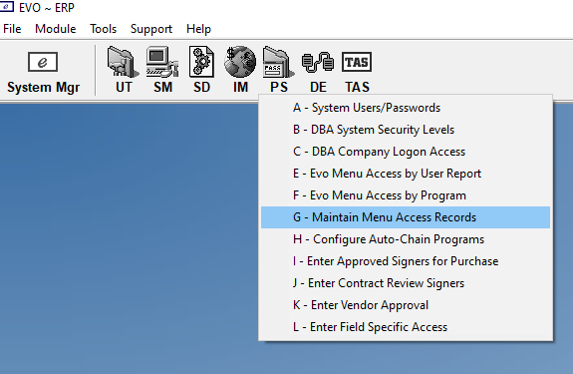
* Click on “**Add Group**”
  + Copy From: “**PROG3**”
  + User(s) to Add To: The new user who wants to use this tool
  + Group To Add: “**Z – Progra**”
  + Click “**Go**”

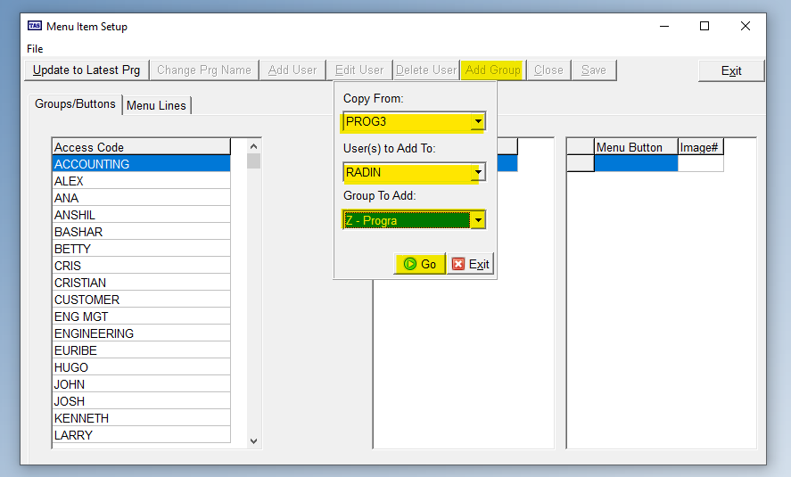

# Using the Tool:

* Open **EVO ~ ERP** and navigate to the menu
* Run the program (located at E://Public/EngineeringTools/EVOPayroll.exe)
* It takes a few seconds, so let it load
* Once the screen titled “**Start Date**” loads, enter in the starting pay period date.  
   **Note**: this application takes most conventional formats in the Month, Day, Year format.  
   I.e. **MMDDYY, MMDDYYY, MM/DD/YY, MM/DD/YYYY, MM-DD-YY, MM-DD-YYYY**
* Click “**OK**”

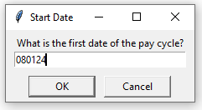

* Enter in the last day of the pay cycle
* Click “**OK**”
* **DO NOT CLICK THE MOUSE OR KEY BOARD UNTIL THE PROGRAM IS DONE**.
  + **Note**: If you need to stop the program in the middle (perhaps if an evo error pops up or it is doing something weird) move your cursor to any corner of the screen and keep it there. This will cause the application to crash safely and stop the program. Note that this will not happen instantly as it waits for the next program input to register the mouse position, so keep your mouse in the corner of the screen until you see the program stop.
* Once the program has successfully completed, you will get the following message: 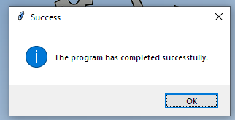

# Reading Data:

* On your desktop there will an excel file named “**EVO_Payroll.xls**”
* The **EVO_Payroll.xls** file will give you information on the total hours that employees have worked for.
* On the bottom you will find a second sheet called “**Detailed Comparison**”
* 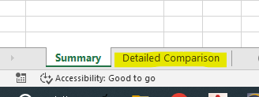
* Here you will find the daily reported hours for every day and employee in that pay period. On the left-hand column (**Column “C”**) you will find the total hours an employee has “**Clocked In**” (the time they arrived in the AM minus the time they left in the PM)
* 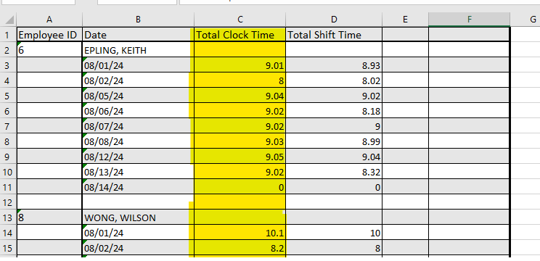
* And on the right-hand column (**Column “D”**) you can see the total hours that an employee has “**Shifted In**” to a certain work order.

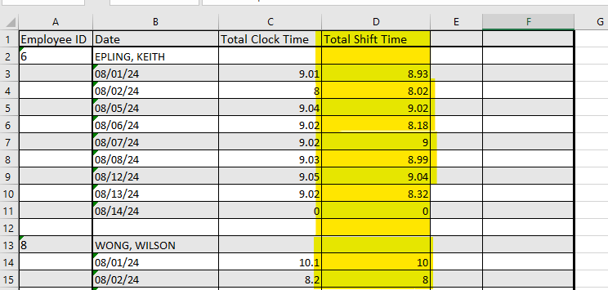

* If there is a significant difference between the shift times and the total clock times, the program will alert you:
  + If the total hours shifted in exceeds the total hours that an employee was clocked in, it will show a red “**MISMATCH**” text
  + On the other hand, if they forgot to shift in and their total shift time is significantly less than their total clock time, it will raise a yellow “**Under-reported**” text

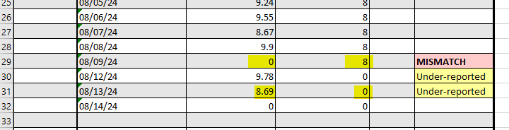

* Edit this sheet to manually override any of the data and hours. (I.e. if you know an employee has worked for 80 hours instead of 78, then you can manually type in the value for the hours. NOTE: Do not change the total hours as that has no impact on the actual data.)
* Once you are satisfied with the payroll report. Run the second application named “**EVOPayrollToADP.exe**”
* Select the finalized “**EVO_Payroll.xls**”, or any other file of the same format that you want uploaded to ADP.

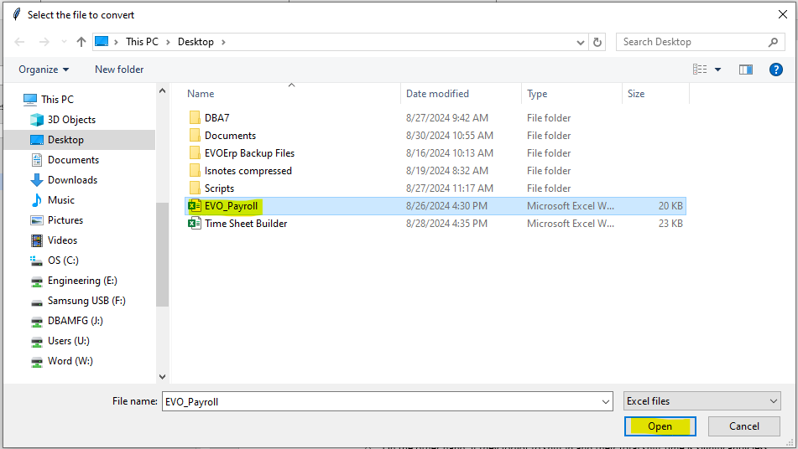

* This will generate a file called ADPUpload.csv file. This is the file that you can use to upload to ADP. This isn’t intended for viewing (unfriendly format), but to be used to import the data into ADP.  
  **Note**: this application will load the data from “**EVO_Payroll.xls**” and not the server, so any changes made to **EVO_Payroll.xls** should be final.